Appendix A
Events on the highway
procedure
Draft
Policy
and
for
highway
management
Peter Bell
24
th
March 2014
Events on the highway

Executive Summary
It is recommended that the police, county and district councils adopt this document as the protocol and outline for the management of road closures for events, parades and other activities that affect the highway network.

It is recommended that the district council is the primary point of contact for applicants, with the police and county council providing a consultation service with published lists of traffic management providers being kept up to date by Lancashire County Council. Furthermore, it is outlined in this report that the use of the Town Police Clauses Act to facilitate the closure is the preferred, first choice, piece of legislation where appropriate.

It is also recommended that Lancashire County Council seeks to create an accredited training programme for marshals to allow county and district employees to be empowered to control traffic when required to do so, if it is deemed feasible by the authority.

Background
In recent years there has been a significant increase in the number of requests to hold events which affect the highway. This increase is partly due to a number of national events such as the Olympic Torch Relay, The Queen's Diamond Jubilee and the Big Lunch. These special events have been over and above the numerous parades, village fetes and events that happen every year within Lancashire.

Each time the highway is used for an event it is necessary to close it to other users. This process helps to ensure the safety of the event patrons, manages highway users' expectations (for example possible delays or diversion routes) and provides a legal framework for the event to occur legitimately.

Road closure powers
There are two main methods that can be used to close, part or all, of a highway for an event. The power is given to the district councils of Lancashire under the Town Police Clauses Act 1847 and to the county council under Section 16A-C of the Road Traffic Regulation Act 1984.

Town Police Clauses Act 1847 (TPCA)
This gives to the district council's powers for preventing obstruction of the streets in times of public procession, rejoicing, or illuminations, and in any case when the streets are thronged or liable to be obstructed.

It may apply to a special occasion when the ordinary day to day use of a street or highway is likely to be obstructed by substantial numbers of people, on foot or in a vehicle, participating as spectators or otherwise in the occasion.

Not all orders under this power need take the form of a full closure

This power is normally used for carnivals and processions where the closure is for a short duration and / or traffic management requirements are not substantial.

It is recommended that the TPCA is used as the preferred method of processing requests to close the highway for events and parades. The advantages of this method are that the order is simple to produce, there are no significant costs and the work can be undertaken fairly quickly, in many cases. To process a TPCA closure, the district council would consult with the police and the county council and where all approve, generate a site notice (Laminated A4 sheet) giving the road closure legitimacy. The only cost for this closure would be the staff time in processing it.

Road Traffic Regulation Act 1984 (RTRA)
This gives the county council the power to make an order to regulate traffic on a temporary basis to facilitate sporting events, social events or entertainment on the highway.

The restrictions may be imposed for a maximum of three days and only one such set of restrictions may be imposed on any particular section of road in a calendar year. Consent to extend the length of time beyond three days and increase the number of events held within a calendar year must be sought from the Secretary of State.

A RTRA closure would follow the same general procedure of consultation; however, it is processed by the county council. The county council as part of the ordering making process will place a notice in the local press over and above the site notice. This will result in an advertisement cost being associated with the order; the amount would be dependent on the newspaper involved.

Furthermore, the permitted frequency of the order means that for events which occur in a local area and potentially use the same sections of highway there is a possibility that subsequent events occurring in the same calendar year would not be able to close the road. For a second closure to be facilitated on a section of highway under the RTRA in a calendar year the county council would need to seek secretary of state approval, on a case by case basis.
Police and the policing of events.
Lancashire Constabulary have recently adopted the Association of Chief Police Officers' (ACPO) 'National Guidance' which means that the police do not undertake any traffic management for an event on the highway other than those events that are deemed, by the police, to be of national importance (such as a Remembrance Day parade).

The requirement for police attendance and action at public events will be principally based on the need for them to discharge their core responsibilities:
- Prevention and detection of crime;
- Preventing or stopping breaches of the peace;
- Action against a breach and subsequent investigation of a closure within the legal powers provided by statute for, a Road Closure Order (Town Police Clauses Act 1847) or a Traffic Regulation Order (Road Traffic Regulation Act 1984);
- Activation of a contingency plan where there is an immediate threat to life and co-ordination of resultant emergency service activities.

It is noted that whilst the police retain discretion to attend and take action at public events in order to discharge their core duties, the ownership for stewarding and marshalling remains with the event organiser

As a result it is the event organiser's responsibility to liaise with the local authority about how the event will be managed and to ensure robust traffic management plans are in place with a suitable number of marshals to enforce it. No event which involves stopping or directing traffic (other than that of a road closure by means of full chapter 8 signage) would be supported by the Police unless the marshals were correctly accredited.

The police recommend that, in the first instance, enquiries with regard to the planning of public events should be directed to the local authority’s Event Safety Advisory Group (ESAG) (discussed later in this report), or they recommend for further information for organisers to visit the Health & Safety Executive website
‘Guidance on Running Events Safely’ (http://www.hse.gov.uk/eventsafety/index.htm).

Holding an event on the highway
The steps that have to be taken to hold an event on the highway need to be clearly defined in a process that is able to be followed by the applicant, irrespective of the legislation used to close the road. An outline flow chart of the proposed process is included in the appendix.

It is recommended that the district council is used as the initial point of contact for the organiser. The district council can then pass the applications to the county council if it is felt that a TPCA closure is not suitable, i.e. a Road Traffic Regulation Act order is required.

Once the application has been received by the district council, the police, the county council and any other key stakeholder will need to be consulted. A recommended mechanism for processing this consultation process is a local Event Safety Advisory Group (ESAG). A number of these exist in the county and it is recommended that an ESAG for each district area is created.

After the ESAG has reviewed the application the district council would then process the TPCA order and notice allowing the legal closure of the road.

ESAG meetings do not need to be held on a regular basis. The meetings are convened as and when they are required.

A requirement of any application for an event will be an effective traffic management plan including the actions that will be taken to ensure the safety of those taking part and other highway users. By requiring the County Council and the Police to approve the traffic management plan the issues around co-ordination with road works and other third party issues affecting the highway are noted.

With the new ACPO policy being adopted nationally by the police traffic management now falls to the event organiser. Traffic management can range from sign only schemes such as "road closed", diversion routes etc, through to accredited event marshals.

Event Marshals
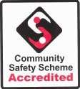

Under the Community Safety Accreditation Scheme (CSAS) it is possible for individuals belonging to larger organisations to become accredited marshals.

The powers that can be granted to a marshal in the area of event management are:
- The power to require giving of name and address;
- The power to control traffic for purposes other than escorting a load of exceptional dimensions.
Other powers are available under CSAS and a link is provided at the end of this document to the complete list of powers and the legislation that provides it.

Within Lancashire there is only currently the AA who has accredited marshals available. These were used at the Open Golf Tournament 2012 in Fylde. The AA also has an accreditation course (accredited by the police) allowing them to train other marshals.

Kays traffic management and Stadium TM are, at the time of this report, looking to train a number of their staff with the AA to become marshals.

The cost of training a marshal with the AA is £450 per person, with the police charging £80 per person for admin and vetting. A total cost of £530.

It would be possible for Lancashire County Council to create a training course which could be accredited to allow us to train our own staff, and possibly the staff of the districts, potentially at a lower cost.

It is recommended that the county council looks at creating an accreditation course to allow us to control the training that marshals receive, ready for them to work on our highway. The powers are also not restricted to just events, so could also apply to instances where emergency traffic management is required where the police are not available (e.g. where there is a failure at a major traffic signal junction).

The police have indicated that they would not support the rolling closure of a road under either TPCA or RTRA if the traffic management plan did not include accredited marshals. Full closures are different as they could be implemented by sign only.

Example process

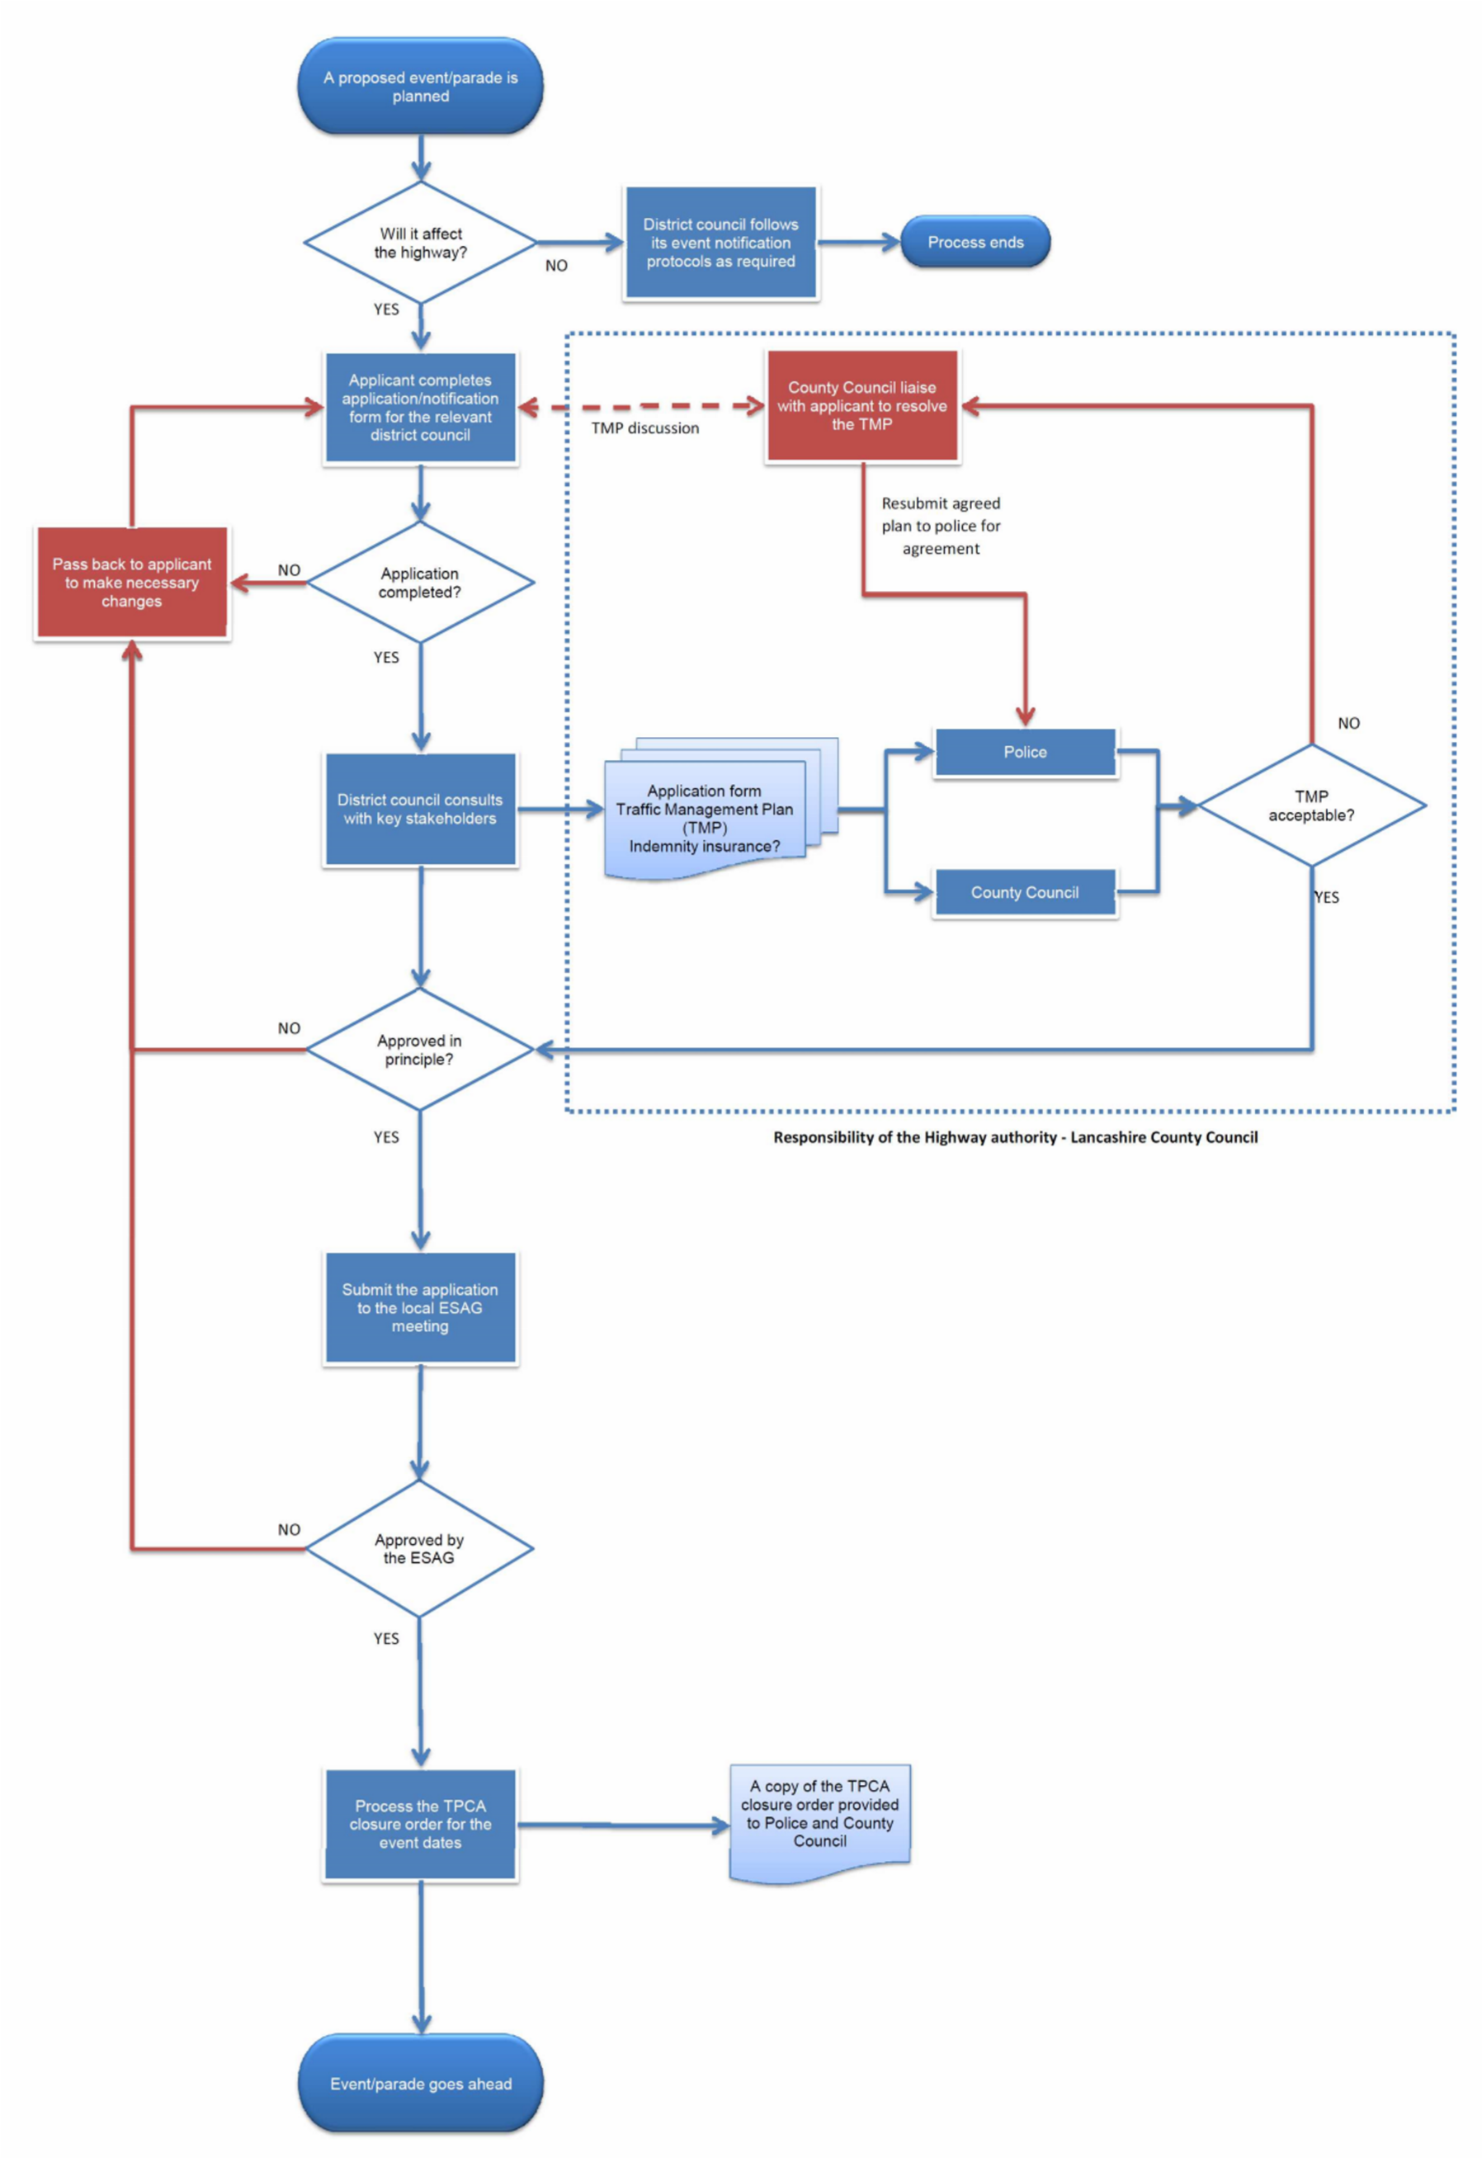 Figure 1 – Sample process for an event on the highway.
As a district delivered process this flow chart outlines an example process. District partners may follow slightly different procedures. However the basic outline of this flow chart would remain the same.

Example documentation

The police have provided the following notes that could accompany any application for a temporary road closure. It would be with agreement with the district councils how the timescales and fees are covered. However it would be advisable to try to agree a countywide consistent set of notes. Flexibility within the items will allow districts to place their own interpretation on certain items, for example "may charge a fee" etc

- The District / County Council(s) may charge a fee for the administration of a closure under either piece of legislation.

- A minimum number of weeks’ notice is required for the processing of a road closure order. Your local district will be able to advise you further on these timescales.

- Under the terms of the legislation, the County Council must be satisfied that it is necessary to close the road in order to facilitate the event.

- The Police / County Council / District Council and other key stakeholders will be asked to comment on the application and attached plans.

- If a road closure is necessary the event organiser will is recommended to contact a traffic management company to prepare a traffic management plan of :- (if necessary)
  - a plan showing positions of the road closure/route diversion signs/barriers;
  - * a description of wording/size/colour of the road closure/ diversion/ signs/barriers; and
  - details of accredited stewards/marshals.

*All signs must conform to The Traffic Signs Manual Chapter 8.

- The event organiser must consult with all residents and businesses which may be affected by the closure.

- Access for emergency vehicles and residents/businesses must be maintained at all times during the closure period.

- Evidence of public liability insurance cover for £5 million must be provided with the application.

- All litter, signs, public notices etc must be removed as soon as possible after the event.

Further information

For further information you can contact Peter Bell (peter.bell@lancashire.gov.uk) or you can refer to the online information below.

Links:
Article on the AA accreditation for the open: http://nationaltraffic.co.uk/viewtopic.php?f=2&t=6161

List of powers available under the CSAS scheme: https://www.gov.uk/government/publications/community-safety-accreditationscheme-powers

Example website from Preston City Council: http://www.preston.gov.uk/yourservices/events/planning-an-event-inpreston/process/

Example form used by Fylde Borough Council:
https://www.fylde.gov.uk/forms/showform.asp?fm_fid=800

